**Course Elements**

The course, **Usability Principles**, will introduce you to the following topics:

* What is Usability?
* The Importance of Usability
* Usability vs User Experience
* Principles of Usability:
  1. *Affordance*
  2. *Alignment*
  3. *Consistency*
  4. *Ease of Use*
  5. *Findability*
  6. *Error Recovery*
  7. *System Feedback*
  8. *Aesthetics*
  9. *Grouping of Information*
* User Experience Heuristics

**What is Usability?**



***Usability is a term given for how we use systems, applications or products and with what effort***.

**Usability** determines the success of a product. It takes meticulous research and planning to make a product **usable**.

**For example**:

* The above image depicts a **USB flash drive**. It is easy to uncap and carry it in your pocket.
* Though it appears to be a **capsule** when it is covered with a lid, it **disguises** itself well and serves as a USB flash drive.

**Benefits of Usability**

**Usable systems result in the following turnarounds for companies:**

* Loyal customers
* Improved reputation
* Competitive advantage
* Minimal training and error costs
* Less support and service costs

**Usable systems provide the following benefits for users:**

* Improved efficiency
* Better productivity
* Enhanced quality of life
* Self-satisfaction

##### Usability is Not User Experience

Let's not get confused **usability** with **user-experience**.

### Usability

Usability is regarding the ability to use a product. The following questions creep up when evaluating usability.

* Are you able to use the product for the expected purpose without confusion?
* Are you able to find the required thing without errors or difficulty?

### User Experience

User experience talks about emotions.

* How do you feel while using the product?
* Does the product offer you a sense of gladness?
* Do you feel important by using the product?

##### Notes on User Experience

User experience is an interesting and a vast topic that we will discuss in the next set of courses. **Here, we will concentrate on usability, because a great user experience cannot be achieved without a significant level of usability.**

**A product that is difficult to use will always produce a poor user experience.**

Now we will look to master usability in the upcoming cards.

##### ****Principles of Usability****

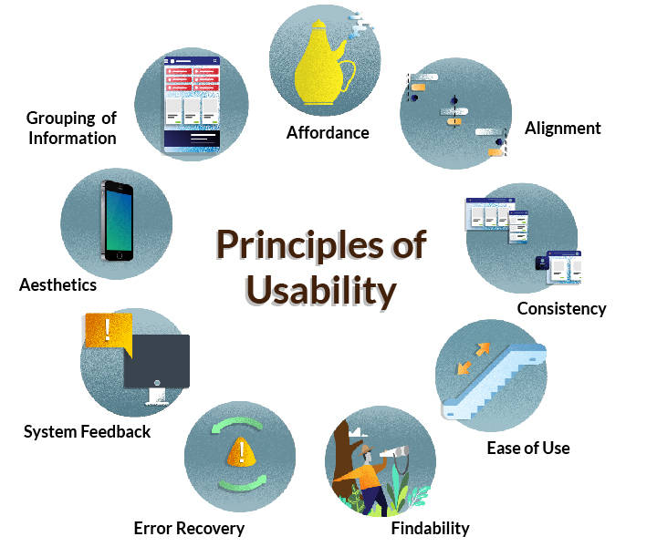

We have realized the importance of usability in the previous cards. So now let’s try to master the key principles of usability.

* + Affordance
  + Alignment
  + Consistency
  + Ease of Use
  + Findability
  + Error Recovery
  + System Feedback
  + Aesthetics
  + Grouping of information

Affordance

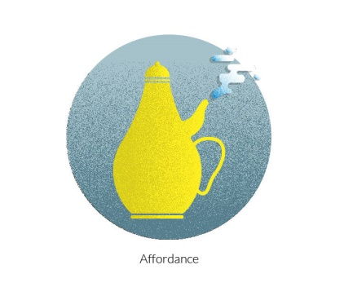

**What is affordance?**

**Affordance** is a perceived idea of how you think you will use an object.

**Why is affordance important?**

Affordance helps you to easily answer the question - **what do you think this object does?**

**Where do you use affordance?**

* In the design of everyday objects – to convey their intended use
* To design icons
* To define clickable or non-clickable entities

Explaining Affordance Through Shadow Play

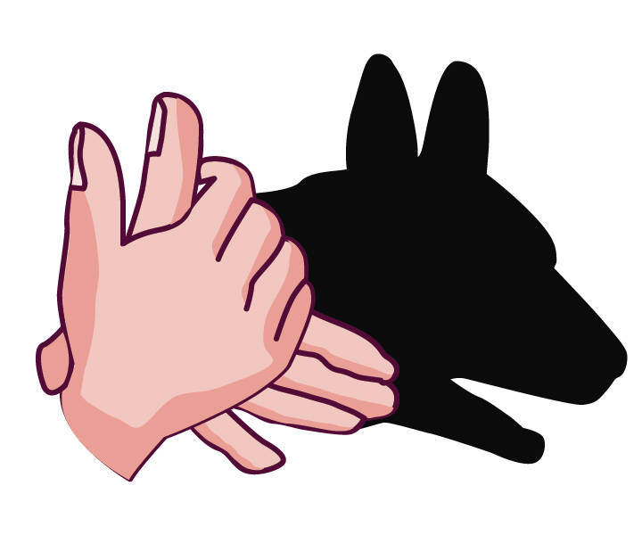

* **What are we trying?**
* **What are we projecting on the screen?**
* **When do we perceive?**

Let's see if we can correlate **affordance** with **shadow play**.

Explaining Affordance through Shadow Play

*Here, hands were used to depict the shadow of a dog through shadow play. What you perceive from an object correlates to affordance.*

*If you were unable to judge that it was a dog? Then affordance fails there.*

Applying Affordance to User Interface

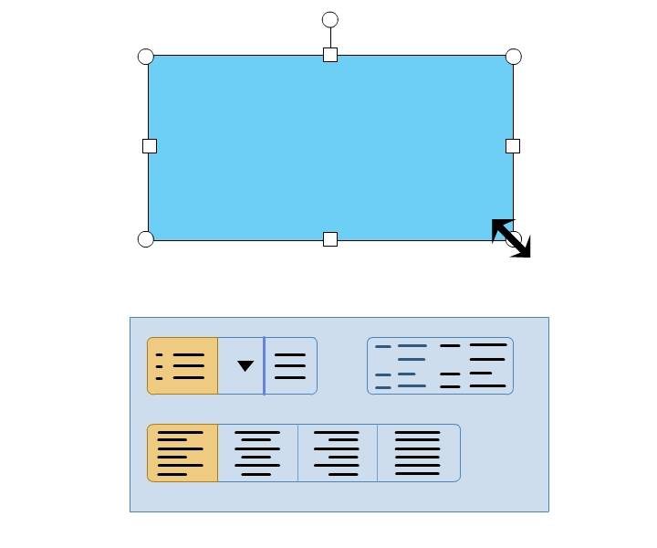

Let's apply affordance to a user interface.

In the first example, the shapes of **mouse pointer** suggest the possible actions. The double-sided arrow pointer and the border around the rectangle indicate that the rectangle can be resized.

In the second example, a set of **clickable** and **non-clickable buttons** are shown. The highlighted beveled effect or border around the icons indicate that the objects are clickable.

 Applying Affordance to User Interface



In the first example, the user interface confuses the user with its styling. In the second example, the styling of the user interface clearly indicates the intended action. The layout and the sizes of the panels set a perception of swiping to view the next slide.

**What is Alignment?**

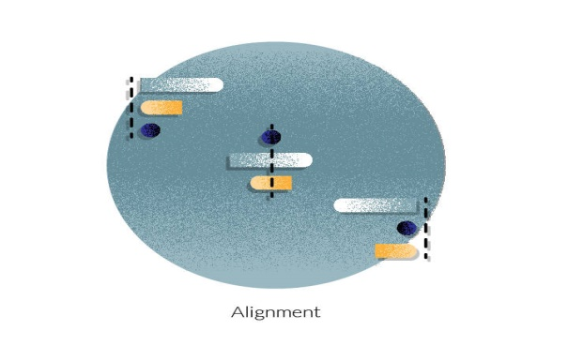

**When you place content in a straight line, or with relative indentations to denote hierarchy in a screen, this arrangement of content is known as** **Alignment**. Relative indentations must be followed consistently in all screens.

**Why is Alignment Important?**

* **Your eyes are always looking to hinge on to a visual guide while scanning content.** The following things can be achieved by aligning content appropriately:
  + Better readability.
  + Understanding information hierarchy clearly by just scanning the content.
  + A pleasant, finished look and feel.

* **Most of us are conditioned to read from Left to Right, Top to Bottom, resulting in an F shaped curve.**
  + When text is aligned to the left, it becomes easier for the eye to move along the F curve.
  + Any indentations automatically convey hierarchy.
* **Misaligned text distorts readability as well as negates any visual cues that could be used to communicate hierarchy.**

**Where do you use Alignment?**

**Adherence to alignment must be followed as a consistent standard in all pages of an application.**

**What is Consistency?**

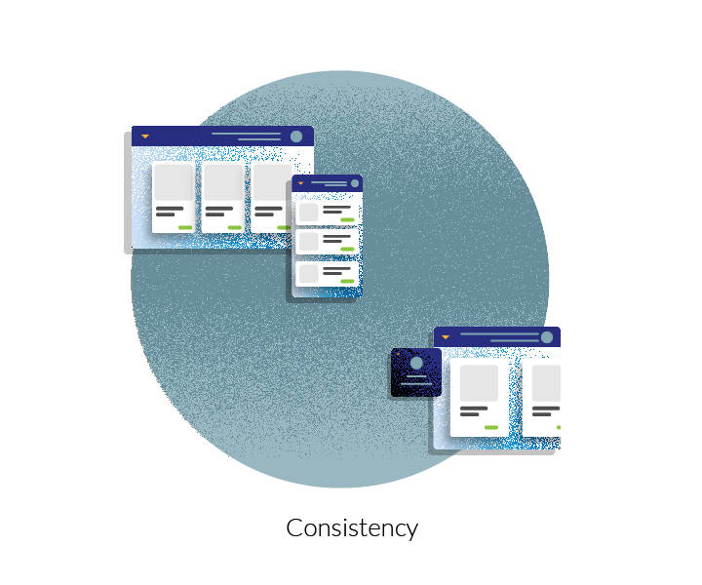

**Consistency is a consistent/uniform behavior noticed throughout all the places in a user interface.** In other words, the same elements are seen at the same place, every time.

**More About Consistency**

**Why is Consistency Important?**

**Consistency** helps in making your experience **predictable**, and therefore it helps in **quick learning**.

**Where do you use Consistency?**

In routine and repetitive work

* To establish branding
* Where standardization is important.

**Consistency in User Interface**

* **Page Elements** – **Header**, **Footer**, and **Navigation**. * The position and styling of the primary interaction elements across the product/application need to be consistent.
* **Colors** * Do not use more than three colors in the entire application. * All similar elements such as headers, links, and titles must be rendered in the same color.
* **Typefaces** * Be consistent in the usage of fonts across the application. * Font styles, sizes, and color should be consistent with the application.
* **Interactions**
  + All the links, buttons, tabs must be consistent in terms of their appearance and behavior.
  + Use same UI controls for similar actions.
* **Content**
  + Use the same language throughout the application unless needed otherwise for business reasons.
  + All the error messages, prompts must use the same tone of language.

**Product Evolution**

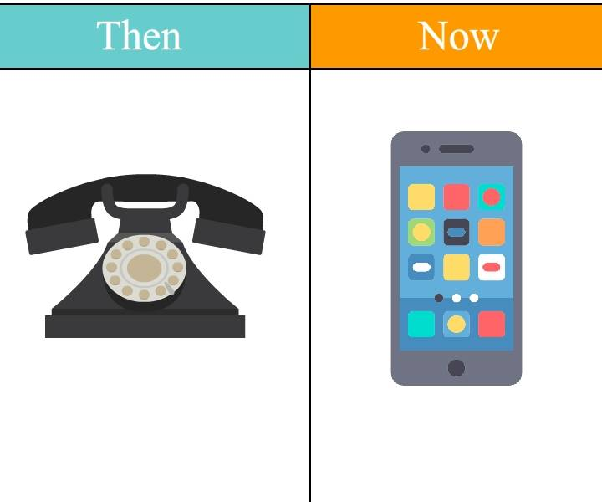

Product designs have evolved in response to user needs and technological developments. The evolution of products will help you to understand the meaning of ease of use.

*The above illustration shows how a traditional telephone has evolved into a smartphone in few decades, thereby improving ease of use.*

**Defining Ease of Use**



**How easily an object can be used without any help is referred to as ease of use**.

**More on Ease of Use**

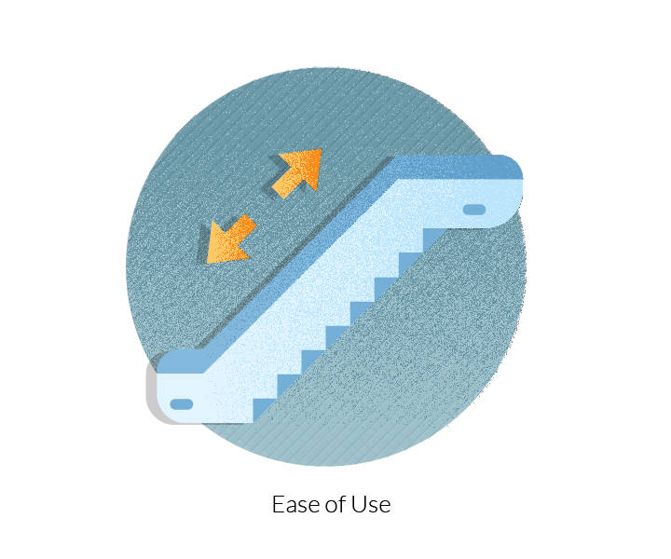

**Why is Ease of Use Important?**

Ease of Use improves the productivity of users by saving time. Users without specialized knowledge can easily use products/applications.

**Where do you apply Ease of Use?**

* Business critical tasks
* High-frequency tasks
* Where fields ordering is important.

**What is Findability?**



**Findability is how easily you can search information on a website as well as from outside the website with the help of search engines.**

*In general, findability is the quality of being found.*

**More on Findability**

**Why is Findability important?**

Findability allows quick retrieval of information. Therefore, it immensely helps in the efficiency of usage. As it helps you to have a constant bearing on your location on the website, it puts you in complete control of your actions.

**Where do you use Findability?**

Search functionality

* Navigation
* Search Engine Optimization
* Accessibility

**Findability in Real Life**



**Maps** are in use for centuries to get to the desired destinations.

**Applying Findability in User Interface**

**Where do you use Findability?**

* **Navigation** * May it be the main menu, breadcrumbs, global navigation or doormat navigation links, findability is of paramount importance. If users do not get to where they want to go quickly, they will lose interest in the application/website. * All the navigation links should be intuitive, direct and to the point.
* **Search** * Search functionality should be quick and accurate. * Advanced search options should be provided wherever. appropriate.
* **Search engine optimization** * Use of appropriate key words to be used by search engines.

**Defining Error Recovery**



*According to the epigram from Alexander Pope's****An Essay on Criticism***,

*To err is human; to forgive, divine.*

**Users must be allowed to recover from their mistakes. This act is known as Error Recovery.**

**Understanding Error Recovery**

**Why Error Recovery is Important?**

Recovery from error saves users from costly mistakes and allows them to revert changes freely.

**Where do you use Error Recovery?**

In critical Tasks

* To forgive users for their mistakes
* Where **undo** is important

**Error Recovery in Real Life**

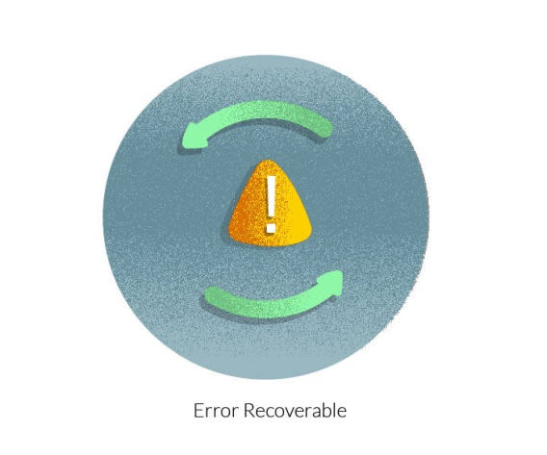

* **Safety nets** and **harnesses** used on construction sites provide a critical chance of recovery from fatal errors.
* At times users land on a screen, from where it is impossible to move away. Users expect some link/button to move away from such screen.
* **Undo** option in an application allows a user to go and revisit the error.

**Defining System Feedback**

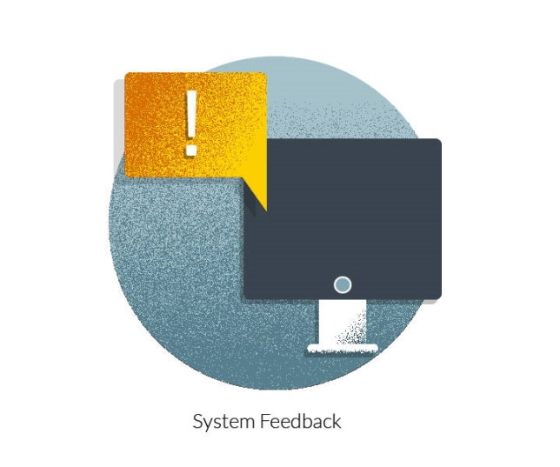

 Whenever a system communicates an appropriate feedback/notification to the user at an appropriate time, it is known as a **system feedback**.

**Understanding System Feedback**

**Importance of System Feedback**

* A system feedback communicates the results of an action – success, failure or work in progress, to you.
* When feedback is conveyed to you, you are aware of the situation.

**Where do you use System Feedback**

* To communicate the success of a user action - **Confirmation**.
* To communicate failure - **Error**.
* Work in Progress – **Progress Bar** and **Loader**.

**System Feedback in Real Life**



The above illustration shows a notification for enabling the GPS location, to book a cab using a mobile app.

**Audio Feedback**

* **Whirring** sound of Automated Teller Machine (ATM) just before cash is dispensed.
* **Beeping** sound when **turn** indicators of the car are on.
* **Ping** sound on mobile phones for a new notification.

**Applying System Feedback to User Interface**

When user creates or edits a record, completes a transaction or is accomplishing a task that will take processing time greater than a 1 second.

**Guidelines for providing feedback**

* **0.1 second**
  + **What user feels** - The system is reacting instantaneously
  + **Feedback required** - No specific feedback is necessary except to display the result.
* **1.0 second**
  + **What the user feels** - the user will feel the delay.
  + **Feedback required** - No specific feedback is necessary. However, the user does lose the feeling of operating directly on the data.
* **10 seconds**
  + **What user feels** - About the limit for keeping the user's attention focused on the dialogue.
  + For longer delays, users should be given feedback indicating when the computer expects to be done.

**Defining Aesthetics**

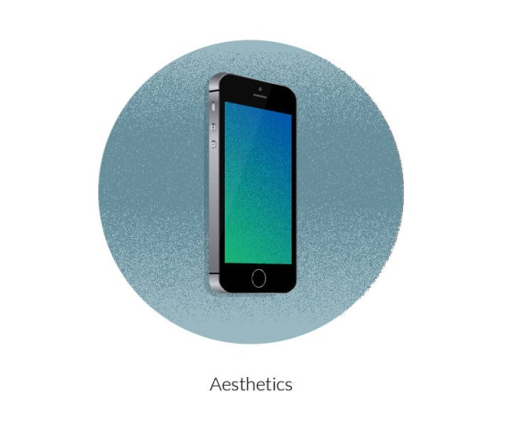

**Aesthetics**is a collection of principles that deal with the appreciation of beauty and nature.

**Understanding Aesthetics**

**Importance of Aesthetics**

A visually appealing and attractive interface not only retains end user’s attention but it also plays a major role in increasing repeat visitors.

**Where do you use Aesthetics?**

* Any work of artistic expressions
* Visual design of an application or a website.

**Quick Fact**

Aesthetics should compliment the content and not compete with it.

**Applying Aesthetics to User Interface**

**Where do you use it?**

* **Colors**
  + Powerful medium to create beautiful interfaces
  + Not to be overused.
* **Typefaces**
  + Styles, sizes, and types can create visual harmony in design.
  + A balance needs to be maintained between aesthetic appeal and legibility of the typefaces.
* **Images**
  + Appropriate use of imagery can add to the aesthetic appeal of the interface.
  + Images must be used to support the content of the application.

**Defining Grouping of Information**

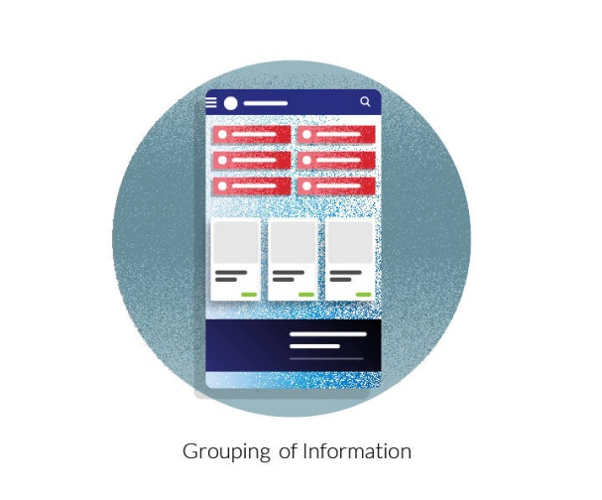

Objects or information with a similar trait is grouped together.

**Understanding Grouping of Information**

**Importance of Grouping of Information**

Grouping helps to understand and process the information easily. It also helps in finding it quickly.

**Where do you use Grouping of Information?**

* Grouping information on informative website such as news
* To design a website menu
* To categorize information